**CE101 Team Report Assignment**

**Team Number- A18 (Replace XX with your team number)**

**Team Members-**

### CSEEJira Project URL: Include link to your team’s jira project

Table of Contents

Chapter 1 The Executive Summary (?? words) 3

Chapter 2 Team Working (?? words) 4

2.I An introduction to Team Working 4

2.II Team Activity Report 4

2.II.a Team's Scrum Meetings, Sprints 4

2.II.b Detailed report of each team members contribution to the project 4

Chapter 3 Product Development (?? words) 5

3.I An introduction to Product Development 5

3.II The Context 5

3.II.a The Customer/ End User 5

3.II.b Legal and Ethical Matters 5

3.II.c Sustainability 5

3.II.d Health and Safety Matters 5

3.III The Team Product 5

3.III.a Product Description 5

3.III.b Product Demonstration 5

Chapter 4: Project Management (?? words) 5

4.I An introduction to Project Management 5

4.II Project Management Report 5

4.II.a Summary of Teams Project management in Jira 6

4.II.b An evaluation of the project management 6

Chapter 5: Conclusions (?? words) 7

# Chapter 1 The Executive Summary (?? words)

This report is concerning the development of the project of predicting the price of houses, based on a data set supplied by Kaggle. The first part explains the dynamics of the teamwork involved within this project, what the theory behind team based working is, and what each individual team member’s role within the project, and their various contributions to the project as a whole. The second part is a review of the development of the software as a whole, with three subsections. The first, is a review into the theory behind product development: The process of developing a product; the methodologies and ideas that exist around product development; design processes and principles; and so on. The section subsection provides a more contextual view for the product within the wider world and environment, primarily covering the legal and ethical concerns, along with both the product’s sustainability and the health and safety precautions surrounding the product. The third subsection covers the technical specification of the product itself: The requirements, functionality and limitations of the software; the design process which was undertaken to develop the software; how the relative design methodologies (namely Agile) were implemented; and the testing process that was used to develop the product. The fourth section is a review of the project management and this is also divided into two subsections. The former is a review on the theories and methodologies concerning project management; the latter is a specific review on how the team handled project management throughout the development of the software. The last section is an overall conclusion, with broad conclusions regarding all elements of the project.

# Chapter 2 Team Working (?? words)

## 2.I An introduction to Team Working

“A group of people in which members work together intensively to achieve a common group goal”. We believe this cite by Lewis-McClear, Kyle and Taylor, M.S (1998) describes best, what team is all about.

“So why should I work in team? I do so much better when on my own!” Well, the number of benefits of team working is significant and there are pretty much no cons if there are any at all. There is an interesting article by ProofHub which includes most of the pros of team working. Firstly, it increases the creativity. Working together on a particular task will raise the levels of enthusiasm for the whole team. This is most likely to result in higher productivity, more meaningful ideas and foster both individual and group knowledge. Team discussions will often end up with having a bunch of good ideas to work on. Teamwork also maximizes the chances of learning from each other experiences. Shared workload and responsibilities is what may be the most important feature of this method. There is nothing better than knowing that you are not on your own and there is someone you can ask for help when you are stuck. Having a variety of characters gives everyone the opportunity to work on what they are most comfortable with, since we are not equally good in pretty much anything. Have fun! Is there a better way to get an important project done than doing it in a funny way? We do not think so. Having a friendly and easy-going environment suggests having fun and less stress on your workplace. Team building and icebreaker activities are a great way to get closer to each other and eventually become life-long friends, not just teammates for a certain project.

However, in order to achieve productive and stress-free environment there is a set of skills which are vital for every team member. Listen! Listening does not just mean being able to hear someone. That is hearing. In order to listen you must be opened up to your collocutor’s ideas and thoughts. It actually means understanding what your teammate is trying to say. When listening is done, the time for sharing opinions starts. Constructive criticism is the key to progress.

## 2.II Team Activity Report

### 2.II.a Team's Scrum Meetings, Sprints

### 2.II.b Detailed report of each team members contribution to the project

James – I worked on the research for the first term of the project, and the team report in the second half of the term. I also was the overall co-ordinator of the team for the project throughout the year. My research was mostly around the implementation of machine learning algorithms, but I also ending up looking into neural networks as a side topic, with a particular focus on Neuro-evolution algorithms. However, these were not eventually needed in the project, but they were an interesting subject to look into and has piqued my interest in the area of artificial intelligence.

# Chapter 3 Product Development (?? words)

## 3.I An introduction to Product Development

Product development can be defined as the creation of entirely new product or the modification of existing one. There are numerous ways of developing a certain new product. Here are three of the most common techniques to develop a project: Ad-hoc, Hacking and the Knott and Dawson methodology.

Ad-hoc, often referred to as build and fix, is known for the poor quality of the created product. The reason for this – there is no actual development process and planning. Hacking is another way to work on a specific project. Generally, there are two ways of thinking about this method. First one, is getting the job done as fast as possible without any considerations of elegance or efficiency. The other one can be seen as producing a solution relying only on pure and great skill. Finally the Knott and Dawson method is an interesting one and it also offers the most efficient and systematic approach. A key point in this methodology is breaking a given problem into a series of tasks. Consequently, this results in structured and time-efficient working process which eventually leads to better and more satisfying products.

If we accept that breaking a long-term goal (problem) into smaller, easier to manage daily tasks a natural question is what will the structure of these tasks be. The following structure is one possible approach. Requirements/Specifications are usually determined through discussion with the customer. Design solutions are something that may vary. It is common for rival companies to offer different design solutions and the user can choose the one that suits him/her best. As a result of the different approaches, competitiveness is *implemented* on the market and the better design usually the one which wins the user’s trust. Even thought that design is a key part of every product, implementation is the stage where the actual creation happens. Without this stage, even the best design would be just a blueprint. Finally, a product must meet the initial expectations and specifications. Therefore, testing is a crucial moment in the product developing process. It should be done regularly, after every completed task in order to make sure that everything is running smoothly and how it is supposed to. Regular checks are important in order to keep in track of the progress. You do not want a finished product and then after the final testing to realised that a particular design solution was not the most efficient and suitable one.

## 3.II The Context

### 3.II.a The Customer/ End User

The end user for a house price prediction software would be anyone on the property market. Be it a first time buyer looking for an affordable property, or multi-property owners looking for how much they could charge, most people would benefit from it. For example, a first time buyer could use it to estimate a property values within an area which they are looking, to see if the prices are within their range, or if they are getting fair prices on an area. Another example of its use would be for prospective house builders to see what prices a house built in an area would go for, and thus be able to determine which materials they could use to ensure they still make a profit. These are just a few examples to how the results from the software could be used.

As for the process of how the user would use the software it is rather simple. The user would input all the various data for use by the algorithm within the software. This would either be an extensive list of all possible variables, or a shortened version to what the algorithm would use. Upon submitting this to the software, using its learnt methods for calculating the house price, it would return a suitable prediction. This prediction would then be used by the user to whatever they need to use it for, be it the potential sale or construction of a house. What this would mean is that valuation of properties would no longer need to be done by estate agents, considering the software eventually became smart enough to perform these predictions far quicker than any human could. What this would do is remove the complexity of choosing an estate agent based on their valuations of the property, and would reduce them merely to a role of middleman between a seller and potential buyer.

### 3.II.b Legal and Ethical Matters

The act of essentially replacing a key role of an estate agent with a piece of software raises ethical concerns. For many, they trust an estate agent to judge the value of the property over a piece of software that is theoretically better than the estate agent, due to the fact that they welcome a friendly face more than an interface. However, it is still likely that estate agents could be used in tandem with the software, rather than being replaced by it. Ideally, they could be used to improve the predictions of the software, and make it better. People would also be hesitant to the software since it uses a form of AI, and people as a whole are resistant to the widespread use of AI in all walks of life, mainly due to media influences, such as hyperbolic news articles, and its representation in movies, notably Skynet from the Terminator franchise. These concerns are not too great for something as menial as predicting the price of houses, but is usually more of a concern when AI with robotic operations occurs, a prime example being an assembly line, due to the fears of unskilled labourers being replaced by robots, and by extension AI. Overall, these issues are minimal for the project, due to the impact area of the software being minimal, since the scope of the software’s functions are narrow.

Legally, the software is sound. Due to there being limited ways to perform the prediction, the form of software we have created would not violate any patents, due to it not having an explicit ‘innovative step’ required for patenting. Additionally, the code written within the university is protected as being the intellectual property of the students. There should also be no legal issues since there is no requirement to commercially distribute the software, and therefore will only be seen within an isolated environment, and thus, would not conflict with any pre-existing copyright or patent that may or may not exist.

### 3.II.c Sustainability

Due to the fact that a piece of software is not very tangible, the sustainability issues for code is very narrow indeed. Since running the software takes energy, it is ideal that the most efficient code is written. However, since the scope of this software is very small, the impact it would have, whether it was the most efficient code possible, or horrendously sloppy, is negligible. Despite this, in the context of predicting housing prices, there is one area of the United Nation’s 2030 Agenda for Sustainable Development that it can be used – Sustainable Cities and Communities. For example, the software, once sufficiently trained, could be used to predict the potential costing of future housing developments, and in order to make the developments affordable, find the combinations for the cheapest possible housing, whilst also making it appealing and safe for potential buyers. Overall, the code is fairly sustainable, as far as software can be.

### 3.II.d Health and Safety Matters

Health and Safety mostly relates to the design and development of the software, and more specifically, the environment that it is created in. Primarily, the Health and Safety (Display Screen Equipment) Regulations 1992 is in regard to the workstation of the computer user. Essentially, the computer lab our group was assigned to complied with almost all of the regulations, however there were a few things that would be flagged up by a DSE workstation assessment. Firstly, the requirement of a screen to be free of glare was sometimes not fulfilled, due to the faultiness of the blinds within the computer lab, and the brightness and contrast settings were not explicitly pointed out to us. In regard to the keyboard, the only issue was that the tiltability of the keyboard was limited, due to the feet allowing for the keyboard to be raised/lowered were broken sometimes, so were not tiltable all the time. For the most part, the workstation followed the rest of the standards and regulations, and any other concerns were negligible. Other concerns to do with health and safety were also accounted for. Since lab sessions were scheduled for no longer than two hours, breaks were unnecessary, and little strain would occur on the body due to being at the workstation for a relatively short space of time.

## 3.III The Team Product

### 3.III.a Product Description

The software that we were tasked with creating was a software capable of predicting house prices. The software operated using machine learning, by analysing information from a large data set, and using the analysed patterns from the large data set to attempt to accurately determine what the price of a house would be, dependant on any of the parameters that are given. In total, there were 79 parameters which could be used to predict the housing price.

Obviously, in the timeframe given, it was unfeasible to determine each of these characteristics’ effects on the sale price, so some were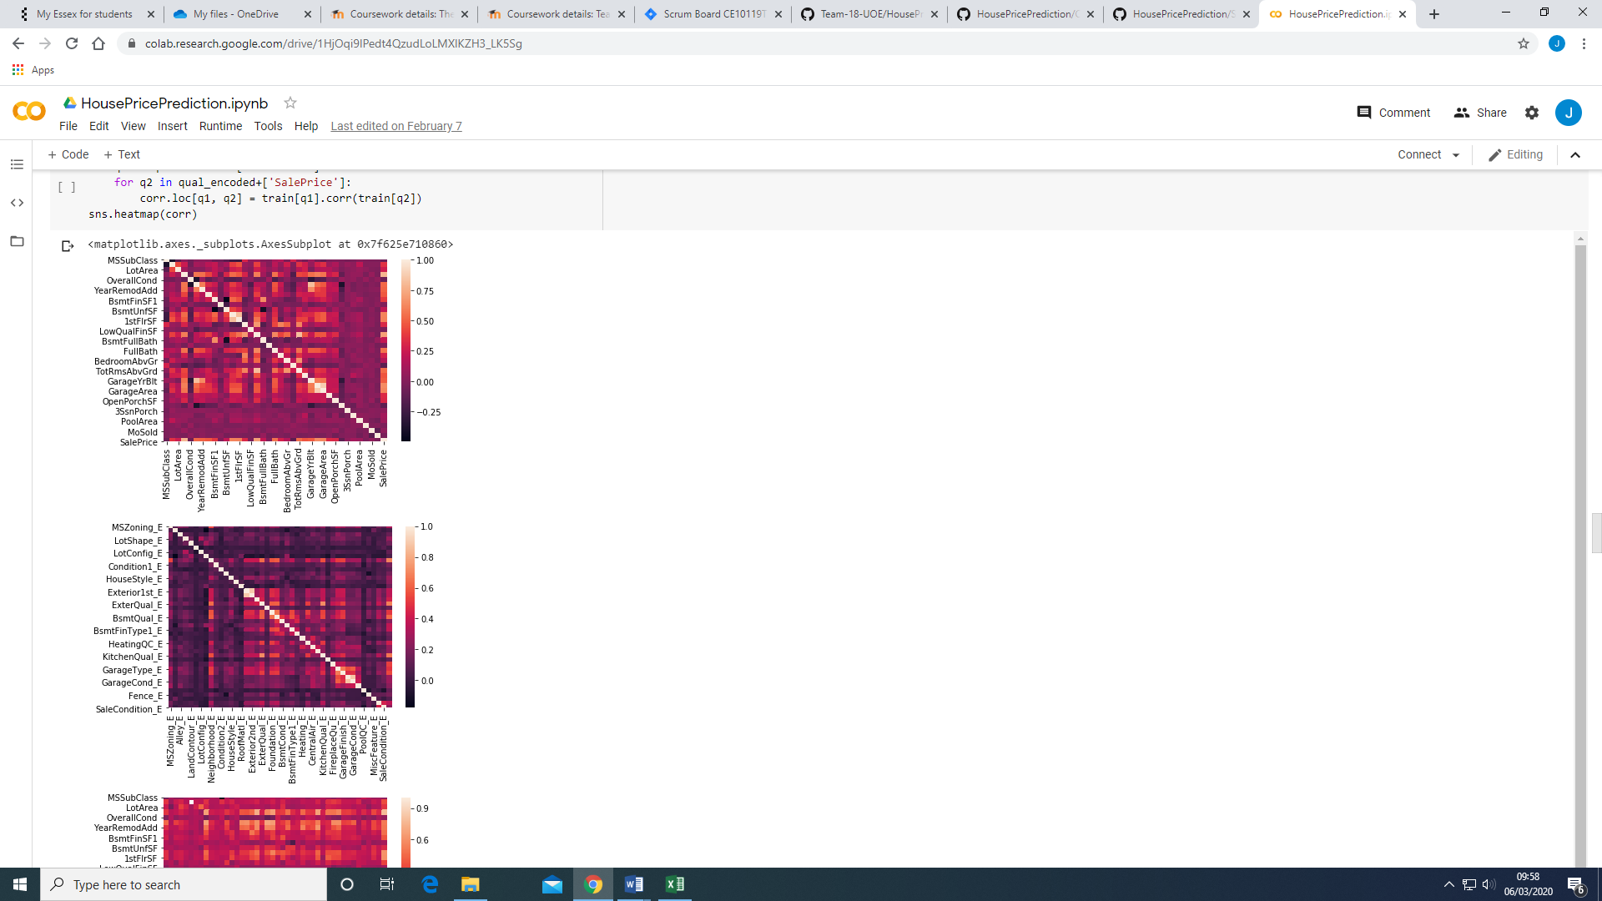 negated. During development, we found that certain parameters had a greater effect on the sale price than others. The heat map on the left shows the correlation between all the variables, with the rightmost column showing the correlation to sale price. In the diagram, the lighter the colour, the higher the positive correlation. Ideally, we were looking for variables that have a correlation closer to 1 or -1 (The darkest areas), since they would affect the house price the most. On the flipside, variables that had a correlation close to 0, would be up for negation from the algorithm, since they had a negligible effect on the sale price. The other problem was dealing with the qualitative variables, since their effect was not as obvious as raw statistical variables. Eventually, these were converted into dummy variables, so they could be handled by statistical measures.

Rather than use forms of neural networks as is typically associated with machine learning, we used forms of regression algorithms to ascertain the predictive values. The theory behind this is that if we could create an accurate model for predicting the house price, it would be far more processor efficient than using an extensive neural network to do the same process. In theory, a neural network could predict the price more accurately, but not only would we have to determine an effective fitness function in order to accurately modify the network to predict correctly, but also neural networks take far longer to train then regression based models. Since we are only having one output, it is also fairly redundant, since neural networks are far more effective when multiple different outputs are required, for example controlling a character in a video game environment, with each output being virtual inputs from a controller. Additionally, the complexity of designing a neural network effectively utilising the 79 parameters that we were given to predict the house price was probably beyond any of the team’s range of abilities at this point in time. However, if we were able to create a neural network, either using a classic learning method or by subjecting it to a genetic learning algorithm (mainly NEAT), it would undoubtably have given us a better prediction, since the program would not predict the values by strictly adhering to the regression model we programmed it with.

### 3.III.b Product Demonstration

# Chapter 4: Project Management (?? words)

## 4.I An introduction to Project Management

A project is a temporary initiative that is executed by a team to achieve a specific goal in our case the house price manager. The main purpose for project management is to manage the three main factors of a project which would be first the time in which we have to complete the project by, the goal when want to achieve aka the output of the project and lastly the cost of the project. The main goal of project management is to make sure that you are prioritising the correct resources for example you wouldn’t take on a task that is not viable or one that depends on another task that is not yet completed. Urgency is another prioritising factor to decide what needs to be done urgently.

## 4.II Project Management Report

House Price estimator, Team 18, James Cridland, Yijing, Joshua Kato, Hristo Georgiev.

Our project was completed on the date that we have set meaning we were right on schedule and this was the cumulative graph of our progress throughout the project

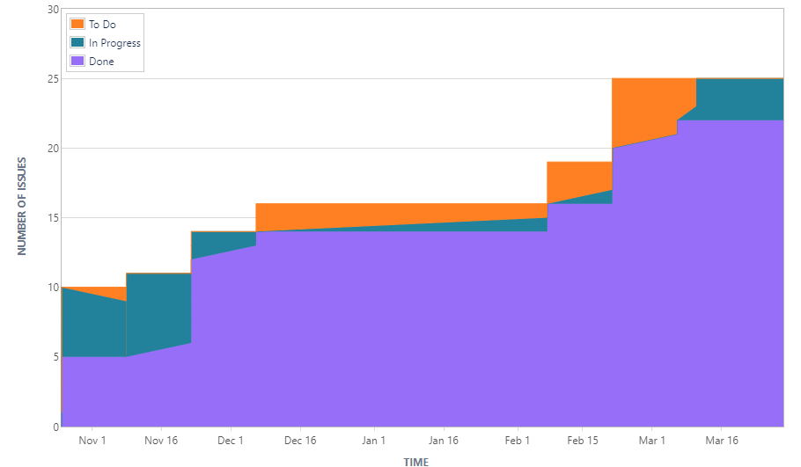

As you can interpret from the graph you can see that we mostly always had something to do and something in progress most of the time the to-do was in progress we tried our best to make sure that we were completing everything we put as to-do so that we would certainly have an output by the end of the project.

Throughout our project we tried to update our Jira board as much as we could making sure that we always had something to do or have progress being made. We were the sole group that had 4 people so this made it hard to be as efficient as we could have been as stated in one of the lectures.” < 5 members results in decreased perspectives and diminished creativity” and because we had less that 5 people, we did feel the disadvantage however, this just meant we had to utilise project management more so the other groups with 5-6 people.

The time spent throughout this project is not too accurate because everyone in the team had their part and it's hard to accurately grasp the actual time put into this project because everyone did a lot of extra work on the side seeing as we had to make up for a missing person. But overall, in a week we would each try to put in at least 6 hours a week including the 2-hour lab spaces we had for our team but most likely more than that because our team also met up after in other labs or stayed a bit longer in that 2-hour lab.

As stated by Katzenbach, J.R. & Smith, D.K. (1993).

"A team is a small number of people with complementary skills who are committed to a common purpose, performance goals, and approach for which they are mutually accountable."

And I believe our team embodied that quote and really used each other's skills which worked in tandem. And we all held each other as accountable and no one was shouted or complained about more than the other members of the team.

### 4.II.a Summary of Teams Project management in Jira

During this project we were advised to utilise the website Jira, Jira is a project management software where we could also use it to help track any issues we had and as a bug tracking tool, its created by Atlassian. we were all given accounts to access our own teams Jira page and it came with a lot of features and functions that we could use to our advantage. One of the many features that we used were firstly a scrum board which was where we mainly put all our stories and tasks in, we could also set the severity of each task stating if they are very important and needed to be completed right away or whether they are not as important to be completed now for example code clean up and improvement. As a part of making the burden lighter on each other we try to change the scrum master around so that it is not always one person who must keep track of all the progress. Jira can also give us a visual representation of our progress throughout our project timeline and this is very important because we are able to look at all the progress of each member and see if anyone needs to contribute more.

### 4.II.b An evaluation of the Project management

In conclusion we used project management to help complete this project and without it most likely it wouldn’t have been able to be completed. Jira was used to create sprints, stories, tasks and issues for our team personally we liked to have a lot of little tasks so that it is easier for us to visualise us

progress for example this picture on the right shows a small number of tasks we set, and this might look like a lot however getting them completed one by one was very methodical and easy to see our progress. We also liked to rotate the scrum master however, as we were coming to a close in the project we all felt it would be easier if one of us remained as the scrum master and kept us all updated on what we should do and this is what we believed to be the most optimal path seeing as James is probably the most organised out of us. We also found that the Kanban board was also a very good way to see what was needed to be done on top of the severity feature of Jira where you can assign how urgently it was needed to be completed.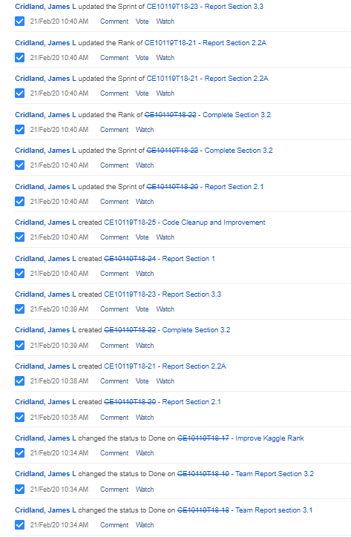

Overall, we were able to complete our project on time and be proud of what we have created in our first year as a team.

# Chapter 5: Conclusions (?? words)

When starting the project, we decided that everyone will focus on a certain task which suit their personal strengths and weaknesses. There are a two main reasons behind this decision. First of all, we did not have equal understanding of the programming concepts needed for this task. Also, our coding experience was quite diverse. Second reason was psychological. Everyone had to feel comfortable and most importantly helpful, throughout the process of developing our final product. We believe this was the only way to stay productive and motivated over the course of the last few months.

We chose James Cridland as our team captain and it stayed like that during the whole process. We stand behind him because he was the most appropriate choice. From characteristic point of view, probably anyone could be a good leader. What makes him stand out as our choice, is the fact that, he was the best prepared all-around member. James contributed a lot to the initial code and played crucial role in creating the foundations of the developed product. He also contributed to the team report by writing some of the sections.

Yijing contributed a lot to the final product. He worked primarily on fixing bugs and improving the code. From programming point of view Yijing probably did the most work. We owe him a lot for achieving our final ranking.

Joshua Kato-Naughton helped the team by searching the web for useful documentation and working on the initial code. He is also the one who worked on chapter 4 of the team report.

Hristo Georgiev contributed to the team by finding helpful information and slightly working on the initial code. However, he played important role in finishing the team report by writing big parts of it.

Generally speaking, about the whole team, we were all motivated and hard-working. However, what really helped us completing this challenge was our consistency, which turned out to be the most important feature of our work. Besides two or three occasions when someone got sick or had health problems, none of us missed lab session. The fact that we stayed efficient during the lab sessions and focused on the common goal, resulted in not having to arrange extra team meetings. Of course, we all had certain tasks to complete at home, but these tasks were individual and did not require other members’ attendance. When it comes to the project management, even thought we did not change our captain, we all played our role. We outlined the most important tasks together, decided who will work on what and finally, James assigned them to the different team members. In conclusion, every single team member contributed as much as they could, given the circumstances and our individual knowledge.